**Mr SGs Linear Motion notes**

**Scalars and Vectors**

-Quantities in physics can be either scalars or vectors

-Scalars can be accurately described using only a magnitude (size) and the appropriate unit

-Scalar measurements do not have a direction

-Examples of scalars include time, distance, volume, speed and temperature

-Vectors cannot be accurately described without giving a direction in addition to the magnitude and the appropriate unit

-Examples of vectors include position, displacement, velocity, acceleration, force and momentum

**Vector diagrams (arrows)**

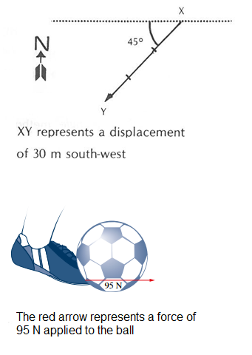

-We often use arrows in physics to represent vector quantities

-The length of the arrow represents the magnitude of the vector

-Vectors can be drawn to an exact scale (with the scale provided), or more commonly, approximately to scale with the numerical value of the vector also provided

-The arrowhead shows the direction of the vector

-For force vectors, the tail of the arrow is drawn at the point of application of the force

-For displacement vectors, the tail of the arrow represents the initial position and the head of the arrow is shown at final position

-Various conventions are used to indicate direction in different types of vector problems

**Vectors in one dimension**

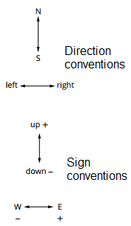

-Vector problems occur in a single dimension when all vectors are aligned (e.g. a gravitational acceleration problem where all forces and motion is occurring directly upwards or directly downwards)

-The **direction convention** refers to the names given to the two possible directions e.g. up/down, backwards/forwards, left/right, east/west etc.

-The direction convention should be presented graphically in all 1D vector problems

-A **sign convention** can also be used, where one designation is defined as being positive and the opposite direction as being negative (e.g. in the up/down convention in the box to the right, a displacement of -100 m would indicate that an object had moved 100 m downwards)

**Vectors in two dimensions**

-Many vectors need to be described in a two-dimensional plane (either horizontal or vertical)

-The horizontal plane is often defined using north/south and east/west axes

-The vertical plane can be defined in various ways, e.g. up/down and left/right or up/down and backwards/forwards

**Horizontal plane**



-Direction in the horizontal plane is described using a quadrant (compass) bearing or a true bearing (preferred method)

-A quadrant bearing represents direction as an angle between north or south and east or west (e.g. S20ºE represents a direction that is from South, 20º towards East)

-A true bearing represents directions as an angle clockwise from north (e.g. S20ºE would become 160 ºT)

**Vertical plane**

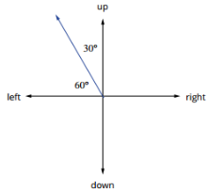

-Directions in the vertical 2D plane are provided in relation to the vertical (up/down) and horizontal (left/right) dimensions

- Vectors are described as an angle and a direction (up/down/left/right) from the horizontal or vertical plane

-The angle shown to the right could be described as “30º down from the vertical to the left” or “60º up from the horizontal to the right”

**Vector addition**

-In physics, we often need to add or subtract vectors

-Vector addition is used when calculating the total (**resultant**) vector from several individual vectors (e.g. attempting to determine the total force acting on an object when it is subjected to multiple forces)

-Vector addition and subtraction can be determined using graphical (scale drawing), algebraic, or geometric methods

-In Year 11 Physics you are expected to perform addition and subtraction of vectors in one and two dimensions, predominantly using algebraic (1D) and geometric (2D) methods

**1D Vector addition**: **graphical method**

**-**The vectors are drawn with each vector having its tail starting at the head of the previous vector

-The **resultant vector** will be a vector with its tail at the tail of the first vector and its head at the head of the last vector



-The magnitude of the resultant vector can be determined from the scale of the diagram if all vectors are drawn to this scale

**1D Vector addition:** **algebraic method (preferred)**

**-**A sign convention is used to represent the direction of the vectors (e.g. up is +, down is -)

-The sign convention is applied to each vector (e.g. a displacement vector of 25 m up becomes +25 m and a displacement vector of 27 m down becomes -27 m)

-When the magnitudes are added together, the resulting sign provides the direction of the resultant vector (sR = (+20) + (-27) = -2.0 m = 2.0 m down)

**2D Vector addition:** **graphical method**

**-**The vectors are drawn with each vector having its tail starting at the head of the previous vector

-The **resultant vector** will be a vector with its tail at the tail of the first vector and its head at the head of the last vector

-The magnitude of the resultant vector is determined by the scale of the diagram

-The direction of the vector is determined using a protractor, referring to the direction conventions of the diagram

-NOTE: This method gives results that are approximate, due to the limits to the precision of the ruler and protractor used

**2D Vector addition: geometric method (preferred)**

-The best way to calculate resultant vectors in two dimensions is by using geometry

-The geometric method relies on constructing a right triangle where the resultant vector is the hypotenuse and the other sides are the individual vectors

-This method can only be used when the individual vectors are at right angles to each other (although as we will later see, vectors can be resolved into components at right angles)

-To use this method, all vectors are drawn head to tail using an approximate scale

-The resultant vector is drawn from the tail of the first vector to the head of the last, forming the hypotenuse of the triangle

-The magnitude of the resultant vector is calculated using Pythagorus’ theorem (the square of the hypotenuse of a right triangle is equal to the sum of the squares of the other two sides)

-The direction of the vector is calculated using trigonometry to calculate the vectors angle from the known sides of the right triangle (SOH CAH TOA)

**EXAMPLE:** A hiker walks 3.5 km North in 40 minutes. He then turns East and walks 4.2 km in 55 minutes. With the aid of a diagram, calculate his final displacement

N 4.2 Ɵ = tan-1(4.2/3.5 ) = 50.2°

sR = √(4.22 + 3.52) = 5.47 km

3.5 sR

Ɵ therefore, the final displacement is 5.4km, 50.2°T

**Vector Subtraction**

-Vector subtraction is often used when finding the difference between two vectors (e.g. finding an object’s change in velocity by subtracting its initial velocity from its final velocity)

-As an example, we would use vector addition to calculate resultant displacement (sR), but vector subtraction to calculate change in displacement (Δs)

-It is most often used to calculate the change in a vector quantity by subtracting the initial vector from the final vector (e.g. change in velocity = final velocity – initial velocity)

-Methods of vector subtraction work on the principle that adding a negative is mathematically equivalent to subtracting a positive (e.g. Δv = v2 – v1 = v2 + (-v1))

-Instead of subtracting an initial vector (v1), you can add the opposite of the vector (-v1), allowing vector addition techniques to be used

**1D Vector subtraction: graphical method**

-When determining the change in a quantity by subtracting an initial vector (v1) from a final vector (v2), the opposite of the initial vector is calculated and added to the final vector

-For the example below, where v1 = 9ms-1 east, -v1 = 9ms-1 west



**1D Vector subtraction: algebraic method (preferred)**

-When subtracting vectors algebraically, opposite of the initial vector is calculated by reversing the sign convention (e.g. multiplying it by -1)

-The procedure is identical to algebraic addition of vectors except the opposite of the initial vector (e.g. -v1) is added in place of the initial vector

Δv = v2 – v1 = v2 + (-v1)

**2D Vector subtraction:** **graphical and geometric (preferred) methods**

**-**2D Vector subtraction is performed the same way as 2D vector addition, but the opposite of the initial vector is added (as per the 1D graphical method for vector subtraction)

-The change in the vector (Δv) will be a vector with its tail at the tail of the final vector (v2) and its head at the head of the opposite of the initial vector (-v1)

-The magnitude of the change in the vector (Δv) can be calculated graphically from a scale diagram or by using Pythagorus’ theorem

-The direction of the vector can be calculated with a protractor from a scale diagram or by using trigonometry (e.g. θ = tan-1(opp/adj))

**Vector Components**

-When adding or subtracting vectors, geometric methods can only be used when the vectors are at right angles to each other (perpendicular)

-When adding/subtracting vectors that are not perpendicular, vectors are resolved into their perpendicular components

-These components describe two vectors in perpendicular planes (normally horizontal and vertical or east/west and north/south) that would add up to form the initial vector

-This is done using the geometric functions sin, cos and tan



-In the example to the right:

sin (20) = opp./hyp. = Fv/45, so Fv = 45 sin (20)

cos (20) = adj./hyp. = Fh/45, so Fh = 45 cos (20)

**Describing Motion: position, distance & displacement**

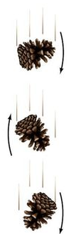

**Simplifying motion: centre of mass**

-The motion of objects is often more complicated than it first appears

-The pinecone on the right is falling from a tree, rotating as it falls

-Because of this rotation, different parts of the pinecone are travelling at different speeds, relative to the ground

-We can simplify the motion of the object by treating it as a single point, acting at its centre of mass (the balance point of the object)

**Frames of reference**

-Whenever we describe the position or displacement of an object, the description will be relative to a frame of reference

-If you are walking slowly down a moving train carriage, your speed will be different relative to different reference frames

-You might be travelling at 5 kmh-1 relative to the train, 90 kmh-1 relative to the earth and 100 000 kmh-1 relative to the sun

-In Yr 11 Physics, we will mostly be looking at the motion of objects relative to the earth, so we can assume that any motion is described with respect to the earth’s surface unless you are told otherwise

**Position (x)**

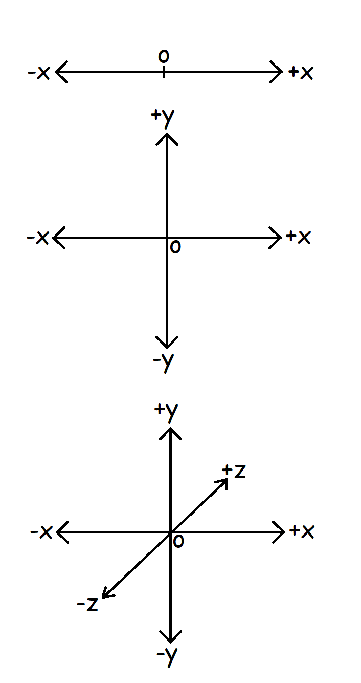

-Position is the location of an object at a given point in time, relative to a reference point (often called the origin)

-Position is a vector, so it needs to be given with a direction

-An objects position can be described in one, two or three dimensions (or axes)

-These axes can be designated as x, y and z or named such as north/south, east/west and up/down

-Direction along axes can be shown with a sign convention (e.g. for 1D motion, positions to the left of the origin can be designated as positive and positions to the right can be designated as positive)

-For 1D motion, position is often given the symbol x, as horizontal motion occurs along the x axis e.g. for an object 10m to the left of the origin, x = -10 m

-For 2D motion, position can be given as a set of (x,y) coordinates e.g. (12 m, -15 m)

-In Yr 11 Physics, we will predominantly be looking at position along a single axis

**Distance (d)**

-Distance travelled (d) describes the total length of the path covered in an objects journey

-It is a scalar measurement of length and as such, it has a magnitude but no direction (distance will always be positive as no sign convention is used)

-As a measurement of length, the unit of distance is the metre (m)

-The total distance travelled by an object is equal to the sum of the distance of all journeys an object has made

**d = d1 + d2 + d3 ………**

**Displacement (s)**

-Displacement is an object’s change in position in a given direction

-It is equal to an objects final position minus its initial position

**s = Δx = x2 – x1**

-As a vector measurement, it must be given with a direction.

-For one-dimensional motion the direction is shown with a sign convention (e.g. forwards = +, backwards = -)

-For two-dimensional motion the direction is shown with a true bearing (e.g. 350° T) or a quadrant bearing (e.g. N 15° W)

-An objects total displacement is equal to the sum of its individual displacements

**s = s1 + s2 + s3 ………**

**Describing Motion: speed & velocity**

-Speed and velocity are both measurements of how quickly an object is moving (the rate of change of position)

-Speed is the rate of change of distance and velocity is the rate of change of displacement

-Both quantities are given the symbol v

-The SI unit for both quantities is metres per second (ms-1), but they can also be measured in kilometres per hour (kmh-1)

-Both quantities can be given as an instantaneous measurement (e.g. rate of change of position at a given moment in time) or an average measurement (how fast an object was travelling over a given time interval)

-An object’s instantaneous speed will be numerically equal to its instantaneous velocity, but the velocity will have a direction (e.g. a car might have an instantaneous speed of 90 kmh-1 and an instantaneous velocity of 90 kmh-1 west)

**Speed (v)**

-Speed is an objects rate of change of distance

-Speed is a scalar quantity, it has a magnitude, but no direction

**Speed vav = distance = d time t**

**Velocity (v)**

-Velocity is an objects rate of change of displacement

-Velocity is a vector quantity, it has a magnitude AND a direction

-For one-dimensional motion the direction is shown with a sign convention

-Speed and velocity are often used interchangeably for one-dimensional motion as their numerical value will be identical

-Average velocity can be calculated from an object’s change in displacement in a given time period

-For an object with a velocity that is changing at a constant rate, it can also be calculated by taking the average of its initial velocity (u) and its final velocity (v)

-Average velocity is calculated using the formulae:

**Velocity vav = displacement = s = v – u time t 2**

**Converting between ms-1 and kmh-1**

-To convert from ms-1 to kmh-1, multiply by 3.6

1 ms-1 = 1 x 3600 mh-1 = 1 x 3600 kmh-1 = 3.6 kmh‑1

1000

-To convert from kmh-1 to ms-1, divide by 3.6

1 kmh-1 = 1 x 1000 mh-1 = 1 x 1000 ms-1 = 1 kmh-1

3600 3.6

**Acceleration (a)**

-Acceleration is the rate of change in the velocity of an object

-For 1 D motion, it can also be calculated from an objects rate of change of speed (e.g. in cases where an objects speed and velocity are identical

-Acceleration is a vector quantity as it is based on displacement, so it is given with a direction

-For 1 D motion this is done with a sign convention (forwards +, backwards -)

-When the forward direction is defined as positive, a positive value for acceleration shows speeding up, and a negative value for acceleration shows slowing down (deceleration)

-As with velocity, acceleration can be measured instantaneously or as average acceleration

-The units for acceleration are meters per second per second (ms-2) or less commonly, kilometres per hour per second (kmh-1s-1)

**a = Δv = (v - u)**

**t t**

**Graphing Motion**

-Even one-dimensional can be complicated when an object is undergoing changes to its position, velocity and acceleration

-It can often be useful to analyse the motion of an object in graphical form

-When plotting motion graphs, it is often possible to obtain further information from the gradient of the line plotted or from the area under the graph

|  |  |  |
| --- | --- | --- |
| Graph  type | Example |  |
| Position-time (x-t) |  | s = Δx  Gradient = Δx = s = v  t t  For curved line, the gradient of a tangent to the curve gives instantaneous velocity |
| Velocity-time (v-t) |  | Gradient = Δv = v-u = a  t  Area under graph = base x height  = v x Δt  = s  If the negative sign is ignored for negative velocities, the area under the graph gives distance instead of displacement |
| Acceleration- time (a-t) | Mechanics - Kinematics - Motion graphs - Page 3 | Area under graph = base x height  = a x Δt  = Δv |

**Equations for uniform acceleration**

-In Physics we will often need to perform calculations involving the displacement, velocity, acceleration or time intervals for objects

-Where an object is undergoing uniform (constant) acceleration, we calculate average acceleration using:

a = (v - u)

t

-This can be rearranged to solve for initial or final velocity

**v = u + at u = v – at**

-When acceleration is uniform, vav = s = u + v

t 2

-Rearranging to solve for displacement gives:

**s = (u + v) t**

**2**



-As shown in the graph to the right, a uniformly accelerating object will have an area under its v-t graph equal to ut + ½ (v-u) t

-The area under a v-t graph gives an objects displacement, therefore we can use the formula:

s = u t + ½ (v – u) t

-Substituting [v – u = a t] into this equation (substituting [a t] for [v – u]) gives us:

**s = u t + ½ a t2**

-Alternatively, substituting [u = v + at] into the equation (substituting [v + at] for u) gives:

**s = v t – ½ a t2**

-Finally, substituting [t = (v – u) / a] into the equation (substituting [(v - u) / a] for t) gives:

**v2 = u2 + 2 a s**

-All problems involving displacement, velocity (initial, final and/or average) and uniform and acceleration are solvable using rearrangements of one of:

**v = u + at s = ½ (u + v)t s = ut + ½ at2 s= vt – ½ at2 v2 = u2 + 2as**

**Vertical Motion**

-In the absence of air resistance, Earth’s gravity will cause the same acceleration of all objects

-Gravitational acceleration is given the symbol g

-Near the Earth’s surface, gravity will accelerate objects at 9.80 ms-2 in the direction of the Earth’s centre, but the values of g will decrease at higher altitudes

-Whether g has a positive or negative sign depends on the sign convention used

-In vertical motion problems, up is typically designated as the positive direction, so the value of gravitational acceleration is given as

**g = -9.8 ms-2**

-Different planets will have different gravitational fields, therefore different values for g

(e.g. gmoon = 1.60 ms-2)

-As gravitational acceleration can be considered uniform near the Earth’s surface, g can be substituted for a in equations of linear motion, providing gravitational acceleration is the only acceleration acting on a body

**v = u + gt s = ½ (u + v)t s = ut + ½ gt2 s= vt – ½ gt2 v2 = u2 + 2gs**